Gen AI with .Net
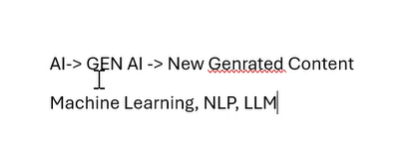
AI vs Machine Learning vs Generative AI
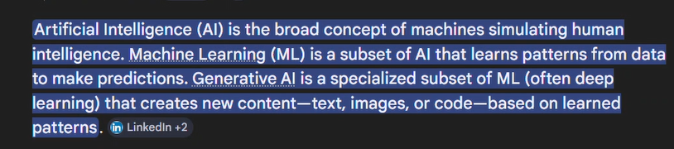

Siri – rules based – machine learning
LLM’s – large language models , pre trained models – for generating images , text , audio , code

RAG – your own data – Retrieval Augmented Data
Google open APIs – login with google account
Integrate AI -> AI SDK (classes & methods) -> access over open API (Gemini , Claude)

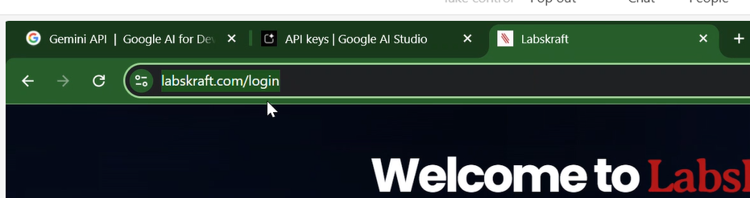

- OpenAI platform
- Aistudio.google.com
- Open.ai
- Claude.ai
- OpenAI – package

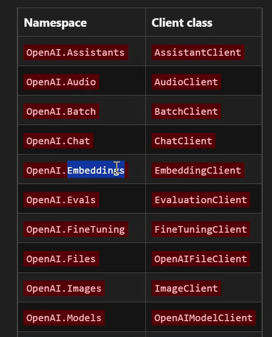
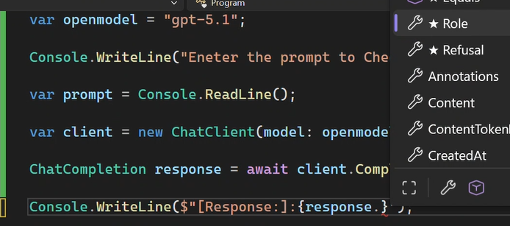
Response.content[0].text

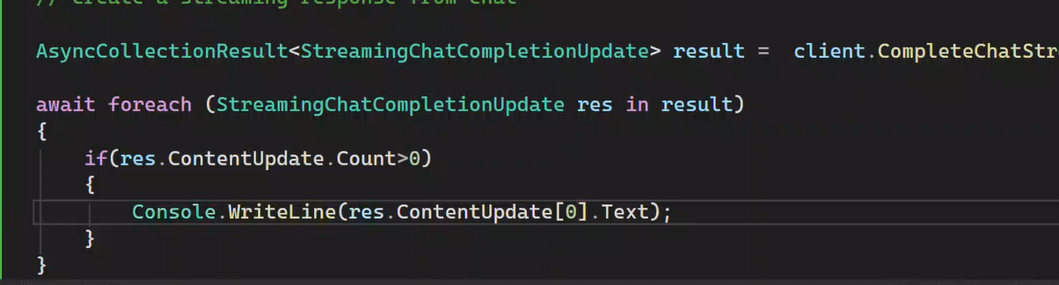
Streaming application
We can implement this as an conversation also .
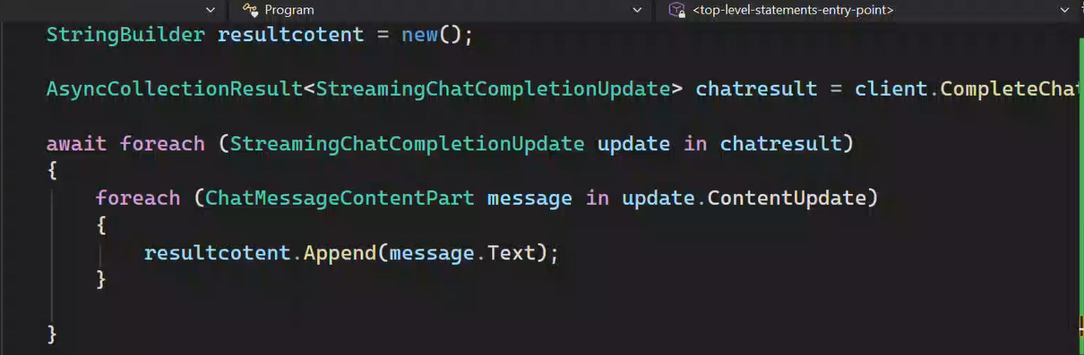
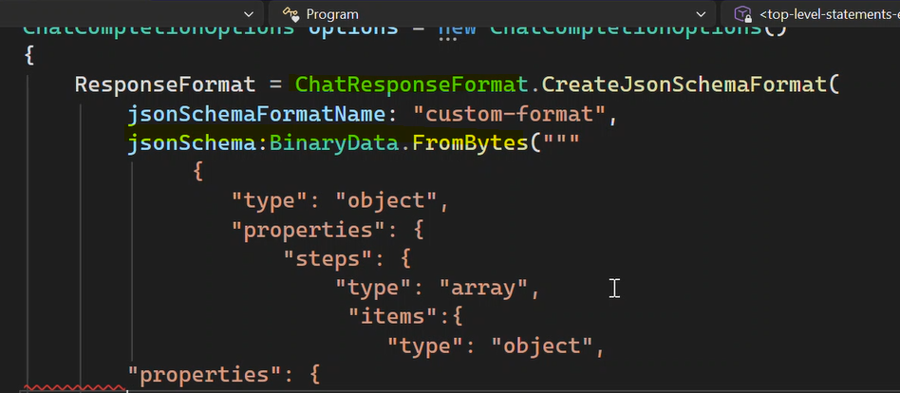
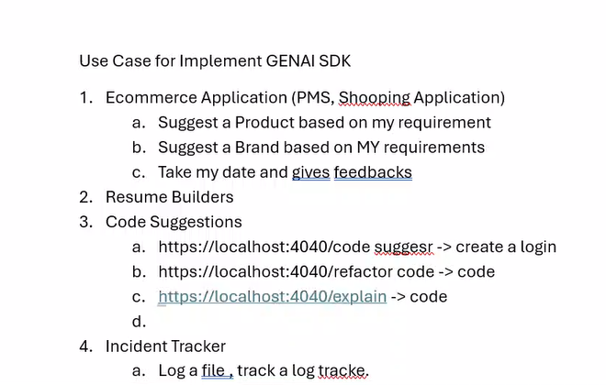
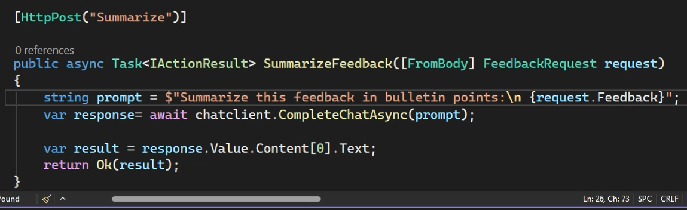
Summarize the feedback , change the feedback from sentiment analysis
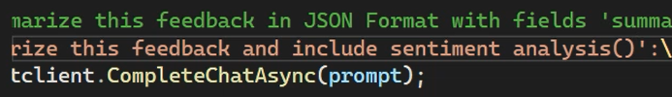
Decision making API
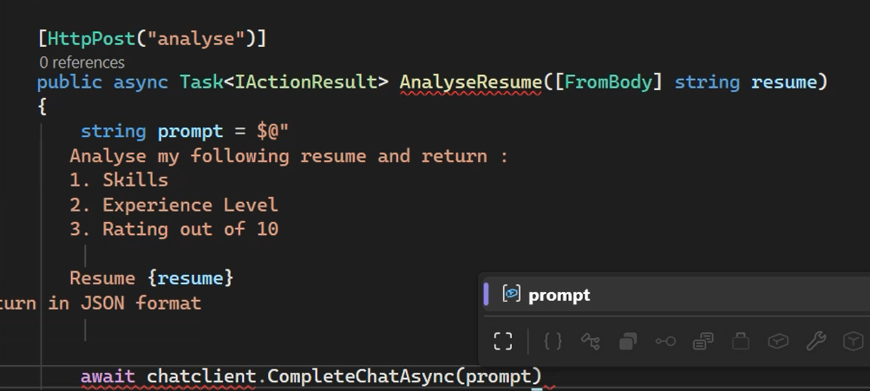
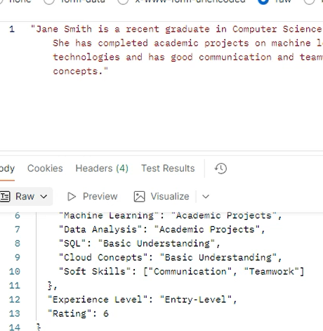

Structured Input to the model

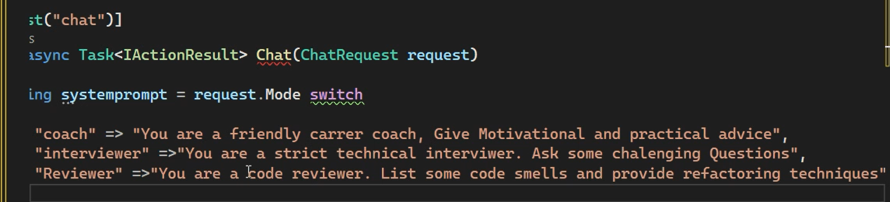

Setting up the API personality based on the mode
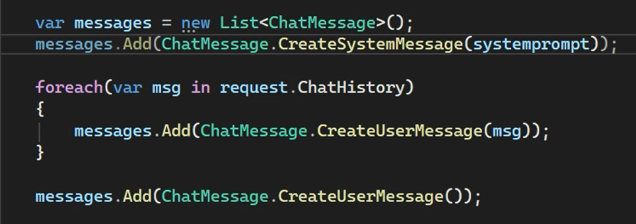

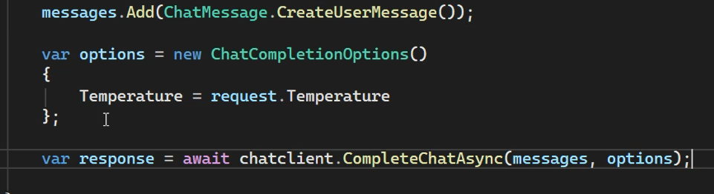
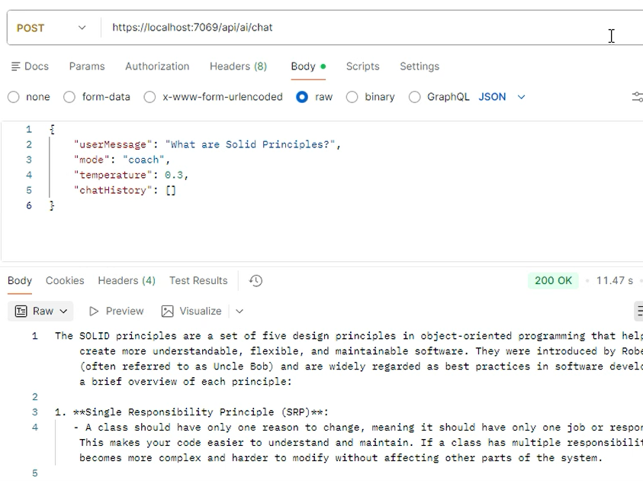
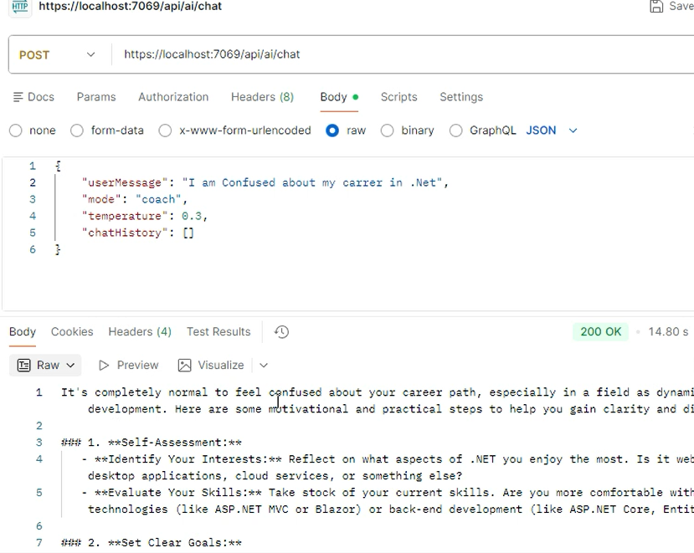

Same AI , it is behaving as different personality , temparatur more means more creative , less means it is plain
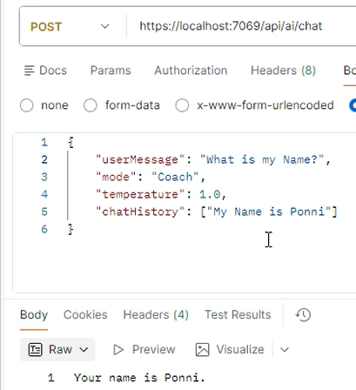
Store the history in the data base

